**RESTAURANT MANAGEMENT SYSTEM**

Submitted By

|  |  |
| --- | --- |
| **Student Name** | **Student ID** |
| Shakib Hassan Munna | 241-15-680 |
| Sidratul Muntaha Oyshe | 241-15-886 |
| Sanchari Saha Tanwi | 241-15-512 |
| Faisal Haque Pramanik | 241-15-302 |
| Akib Rownak Alam | 241-15-490 |

Restaurant Management System

This Report Presented in Partial Fulfillment of the course **CSE124: Data Structure** in the **Computer Science and Engineering Department**



**DAFFODIL INTERNATIONAL UNIVERSITY**

Dhaka, Bangladesh

December 9, 2024

**DECLARATION**

We hereby declare that this lab project has been done by us under the supervision of **Md. Abbas** **Ali Khan**, **Assistant Professor**, Department of **Computer Science and Engineering**, Daffodil International University. We also declare that neither this project nor any part of this project has been submitted elsewhere as lab projects.

SUBMITTED TO:

______________________

**Md. Abbas Ali Khan**

Assistant Professor

Department of Computer Science and Engineering

Daffodil International University, Dhaka

SUBMITTED BY

|  |  |
| --- | --- |
| ____________________  Shakib Hassan Munna  241-15-680  Dept. of CSE, DIU | |
| ____________________  Sidratul Muntaha Oyshe  241-15-886  Dept. of CSE, DIU | ____________________  Sanchari Saha  241-15-512  Dept. of CSE, DIU |
| ____________________  Faisal Haque Pramanik  241-15-302  Dept. of CSE, DIU | ____________________  Akib Rownak Alam  241-15-490  Dept. of CSE, DIU |

**COURSE & PROGRAM OUTCOME**

The following course have course outcomes as following:

Table 1: Course Outcome Statements

|  |  |
| --- | --- |
| CO’s | Statements |
| CO1 | Apply the concept of stack, queue, tree and graph to create and manipulate new data types for solving real-life problems having complex engineering attributes. |
| CO2 | Solve a real-life problem having application of abstract data type created within the scope of complex engineering problem solving. |
| CO3 | Apply the knowledge attained in problem solving using team projects. |
| CO4 | Apply technique to implement the project. |

Table 2: Mapping of CO, PO, Blooms, KP and CEP

|  |  |  |  |  |
| --- | --- | --- | --- | --- |
| **CO** | **PO** | **Blooms** | **KP** | **CEP** |
| CO1 | PO3 | C3 | KP5 | EP6 |
| CO2 | PO2 | C3, P4 | KP1 | EP2 |
| CO3 | PO9 | A1, A2 | KP5 | EP1 |
| CO4 | PO2 | P2 | KP1 | EP2 |

The mapping justification of this table is provided in section 4.3.1, 4.3.2 and 4.3.3.

**Table of Contents**

**Declaration** **I**

**Course & Program Outcome** **II**

1. **Introduction** **1**
   1. Introduction 1
   2. Motivation 1
   3. Objectives 1
   4. Feasibility Study 1
   5. Gap Analysis 2
   6. Project Outcome 2
2. **Proposed Methodology/Architecture** **3**
   1. Requirement Analysis & Design Specification 3
      1. Overview 3
      2. Proposed Methodology/ System Design 3
      3. UI Design 4
   2. Overall Project Plan 4
3. **Implementation and Results** **5**
   1. Implementation 5
   2. Performance Analysis 5
   3. Results and Discussion 5
4. **Engineering Standards and Mapping** **9**
   1. Impact on Society, Environment and Sustainability 9
      1. Impact on Life 9
      2. Impact on Society & Environment 9
      3. Ethical Aspects 9
      4. Sustainability Plan 9
   2. Project Management and Team Work 9
   3. Complex Engineering Problem 10
      1. Mapping of Program Outcome 10
      2. Complex Problem Solving 10
5. **Conclusion** **11**
   1. Summary 11
   2. Limitation 11
   3. Future Work 11

**References 12**

**Chapter 1**

**Introduction**

* 1. **Introduction**

A Restaurant Management System (RMS) uses various data structures to efficiently manage operations like menu handling, order processing, reservations, and inventory management. Data structures such as arrays (for menus), queues (for orders), hash maps (for quick lookups), and binary search trees (for sorted reservations) help streamline processes by organizing data logically and enabling quick access. These structures ensure scalability as the restaurant grows and improve decision-making by providing well-structured data. Efficient use of data structures also reduces delays, enhancing the overall customer experience.

* 1. **Motivation**

The motivation for a Restaurant Management System (RMS) is to streamline operations, improve efficiency, and enhance customer experience. It automates tasks like order taking, billing, and kitchen coordination, reducing errors and saving time. The system tracks inventory in real-time, controls costs, and supports multiple payment options. It enhances staff productivity, improves table turnover, and provides insights through data analytics, enabling better decision-making and increased profitability.

* 1. **Objectives**

The main objectives of a Restaurant Management System (RMS) are to streamline operations, enhance customer experience, and improve efficiency. It automates tasks like order processing, billing, and inventory tracking, reducing errors and delays. The system supports cost control, waste reduction, and multiple payment options, enhancing customer satisfaction. It also boosts staff productivity and provides data analytics for better decision-making and increased profitability. Additionally, it helps optimize resource allocation and improve overall business performance.

* 1. **Feasibility Study**

A feasibility study for a restaurant management system involves evaluating market demand, analyzing location suitability, assessing competition, and creating financial projections. It also includes outlining operational requirements, ensuring legal compliance, identifying technological needs, and assessing risks. By thoroughly analyzing these factors, the study helps identify potential challenges and develop strategies to mitigate them. This comprehensive approach ultimately improves the chances of success for the restaurant management system project.

* 1. **Gap Analysis**

A gap analysis of a restaurant management system involves identifying discrepancies between the current and desired states. It includes assessing current functionality, gathering stakeholder feedback, defining clear objectives, and pinpointing necessary improvements. The process highlights gaps such as outdated technology or manual processes needing automation. Prioritizing these gaps based on business impact, an action plan is created with specific actions and timelines. Solutions are then implemented, and the system's performance is continuously monitored and reviewed to ensure alignment with business objectives. This analysis provides a roadmap for achieving desired improvements.

* 1. **Project Outcome**

The outcome of a restaurant management system project includes several key benefits. It improves efficiency by streamlining processes like order taking and billing, enhances customer experience through reduced wait times and accurate orders, and ensures better inventory management to reduce wastage. The system enables data-driven decision-making with detailed reports and analytics. It increases revenue by optimizing operations, ensures compliance and security, improves staff productivity through task automation, and provides a competitive advantage in the market. These outcomes contribute significantly to the restaurant's overall success and profitability.

**Chapter 2**

**Proposed Methodology/ Architecture**

### Requirement Analysis & Design Specification

* + 1. **Overview**

A restaurant management system optimizes operations by managing orders, billing, and inventory. It handles online and phone reservations, staff scheduling, attendance tracking, and payroll. The CRM component manages customer data and engages customers through loyalty programs. Overall, the system enhances efficiency, improves customer experience, and supports data-driven decisions, contributing to the restaurant's success.

* + 1. **Proposed Methodology/ System design**

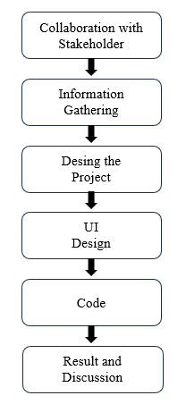

Figure 2.1.2.1: Methodology/ System Design

**Collaboration with Stakeholder:**

Traditional restaurant management methods like manual reservations, order-taking, and billing are time-consuming and error-prone, especially as data grows. These inefficiencies can lead to delays and poor customer experiences. A digital restaurant management system streamlines operations, reduces errors, and enhances service quality.

**Information Gathering:**

We collected data from nearby restaurant and we started creating a project based on restaurant management system.

**Design the Project:**

A digital restaurant management system will streamline operations with modules for reservations, order management, inventory tracking, and automated billing. It will include a CRM to store customer data for personalized service and loyalty rewards. Analytics and reporting tools will provide insights to optimize efficiency and improve decision-making.

**UI Design:**

In our project, there will be multiple interfaces. First, there will be welcome interface. In the interface there will be the names of the developers. The interface looks like this:

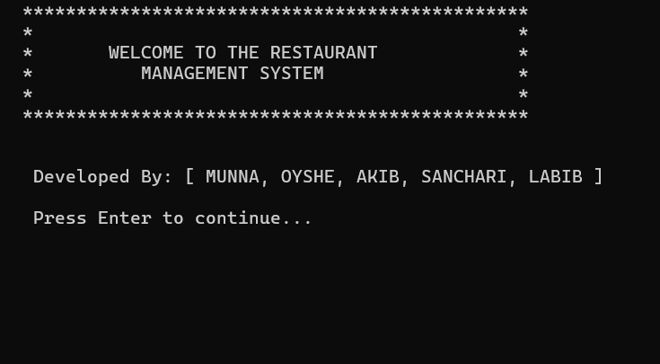

Figure 2.1.2.1: **Welcome Interface**.

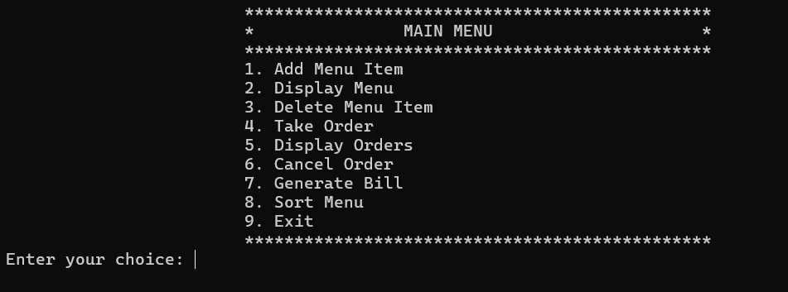

Figure 2.1.2.3: Main Interface.

**Code:**

We made our project using C programming language. Here are some main parts of our project code:

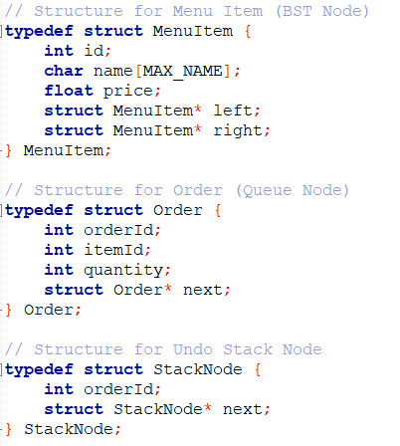

Figure 2.1.2.4: Structure

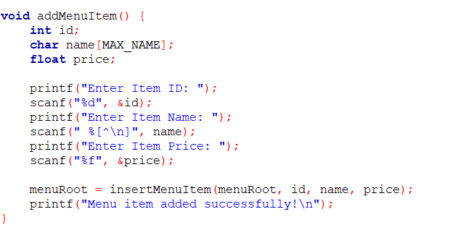

Figure 2.1.2.5: Adding

**UI Design**

1. **Welcome page**
2. **Main Page**

**2.2 Overall Project Plan**

Developing a restaurant management system involves several stages. Start by defining objectives, identifying stakeholders, and conducting a feasibility study. Plan by gathering requirements, defining scope, creating a budget, and setting a timeline. Design the system architecture and user interface, then proceed with coding and regular reviews. Test the system through unit, integration, and user acceptance testing. Deploy by setting up the environment, migrating data, and launching the system. Provide training and support to users, monitor performance, gather feedback, and make improvements. Ensure regular updates and ongoing technical support. This comprehensive plan ensures the system's successful development and implementation.

**Chapter 3**

**Implementation and Results**

**3.1 Implementation**

Implementing a restaurant management system involves several steps to ensure a smooth transition. First, plan by setting objectives and assigning roles. Configure the system to meet the restaurant's needs and migrate existing data. Integrate the system with other tools and conduct thorough testing. Train staff on the new system, prepare for the go-live date, and closely monitor performance after launch. Provide support to address any issues, and conduct a post-implementation review to assess and improve the system. This approach ensures effective implementation and enhances restaurant operations.

**3.2 Performance Analysis**

Not applicable for this project.

**3.3 Result and Discussion**

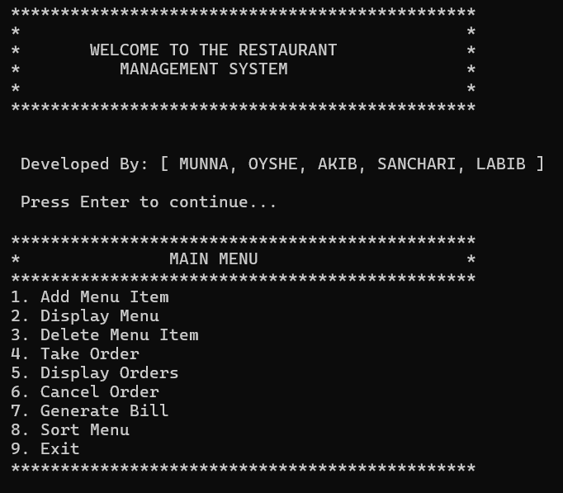

Figure 3.3.1: The user interface

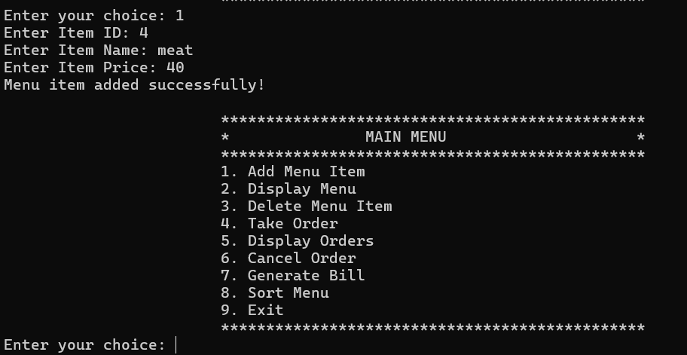

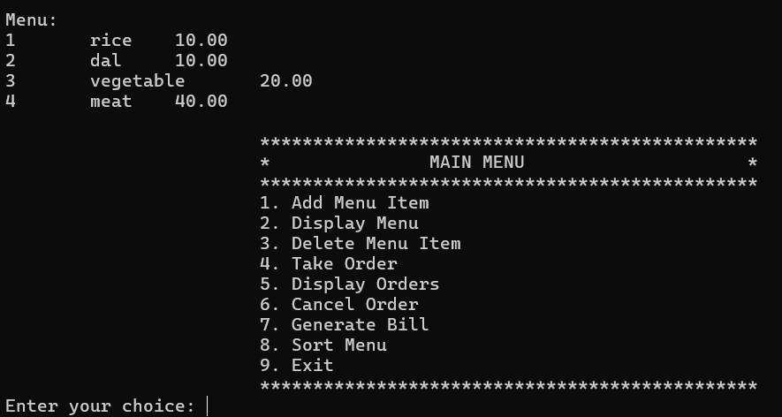Figure 3.3.2: Adding items like this

Figure 3.3.2: Display menu

**Chapter 4**

**Engineering Standards and Mapping**

### Impact on Society, Environment and Sustainability

### Impact on Life

A restaurant management system improves efficiency and enhances customer and staff experiences. Customers benefit from faster service and accurate orders, while staff enjoy reduced manual tasks and better scheduling. Managers gain valuable insights from detailed reports. Financially, it cuts costs through better inventory management and optimized staffing. Secure handling of transactions and data reduces risks. Overall, the system boosts productivity and satisfaction, leading to a successful and smoothly operated restaurant.

### Impact on Society & Environment

1. A restaurant management system boosts job opportunities, improves staff conditions, enhances customer experiences, and supports local economies. Environmentally, it reduces food waste, optimizes energy use, and promotes sustainable practices, benefiting both people and the planet.

### Ethical Aspects

### Chatgpt

### Geekforgeeks

### Cp Algorithm

### Sustainability Plan

A restaurant management system enhances sustainability by reducing waste, optimizing energy use, sourcing sustainably, and minimizing paper waste. It also manages costs, increases customer satisfaction, and fosters innovation. It improves employee well-being, engages with the community, and ensures excellent service. Regular audits and continuous improvement ensure long-term viability.

### Project management and Team Work

### Project Management: A structured approach will be followed, including planning, development, testing, deployment, and maintenance, using project management tools for tracking.

### Team Work:

### Munna: Designed and developed the start page.

### Akib- Created the user page for reservations and orders.

### Labib: Assisted with system integration and user support.

### Oyshe: Ensured functionality and smooth operation.

### Sanchari: Ensured data security.

### Complex Engineering Problem

In this section, provide a mapping with problem solving categories. For each mapping add subsections to put rationale (Use Table 4.2). For P1, you need to put another mapping with Chapter

* Engineering Standards and Mapping.
* Complex Engineering Problem.
* Knowledge profile and rational thereof.

### Knowledge profile and rational thereof

### 4.3.1 Mapping of Program Outcome

Table 4.1: Justification of Program Outcomes

|  |  |
| --- | --- |
| **PO’s** | **Justification** |
| PO1 | Justification of PO1 attainment |
| PO2 | Justification of PO2 attainment |
| PO3 | Justification of PO3 attainment |

**4.3.2 Complex Problem Solving**

Table 4.2: Mapping with complex problem solving.

|  |  |  |  |  |  |  |
| --- | --- | --- | --- | --- | --- | --- |
| **EP1**  Dept. od Knowledge | **EP2**  Range of Conflicting Requirements | **EP3**  Depth of Analysis | **EP4**  Familiarity of Issues | **EP5**  Extent of Applicable Codes | **EP6**  Extent  Of Stakeholder Involvement | **EP7**  Inter- dependence |
| $$√$$ | $$√$$ |  |  |  | $$√$$ | $$√$$ |

**Chapter 5**

**Conclusion**

**5.1 Summary**

A restaurant management system helps run a restaurant smoothly. It handles sales and payments, tracks inventory, manages reservations, schedules staff shifts, stores customer info, and provides reports on sales. It also allows easy updates to the menu, improving efficiency and customer experience.

**5.2 Limitation**

The system may face challenges like high initial costs, reliance on technology, and potential data security issues. Staff training is also required for smooth adoption.

**5.3 Future Work**

Restaurant management systems can be costly to set up and may require ongoing maintenance. They also depend on internet connectivity and can be complex to use, with potential integration and customization limitations.

**Reference**

[1] Geeksforgeeks: Data Structures and Algorithms in C" by Adam Drozdek